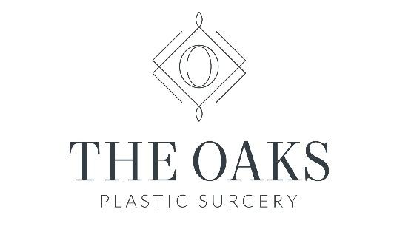
Dr. Danielle Andry
Dr Nandi Wijay

4306 Yoakum Blvd, Suite 520
Houston, Texas 77006

Office: (832) 900-7070

Dr. Andry Post- Operative Breast implant removal Regimen:
- Depending on your specific needs, you may wake up with an ACE wrap dressing or postoperative bra
- After surgery, take the following medications:
  - Celebrex 100 mg twice a day
  - Tylenol 1,000 mg twice a day
  - Antibiotic as prescribed
  - Anti-nausea medication when/if needed
  - Tramadol when/if needed as prescribed
- You may have some drain tubes present that your nurse or Dr. Andry will teach you to use in the post-operative area. It is important that you keep a record of the fluid that has accumulated and that you empty the drains when they are half full or at least twice daily. Bring the record of recorded fluid to your appointment so that Dr. Andry can determine when they are ready to be removed.
- The evening of surgery, you should walk around the house and can even get a very casual dinner, as long as you do not drive or exert yourself in any way.
- You can shower 2 days after surgery. Make sure you have someone to assist you getting into and out of the shower. Do not scrub any incisions; just simply let soap and water run over the areas. Do not submerge any incisions.
- No heavy lifting > 10 lbs for 6 weeks. No activating your pec muscles for 6 weeks after surgery. No strenuous activity that gets heart rate up for 4 weeks. After 4 weeks, you can start doing some activity that does not involve any bouncing or bounding (this includes running, jumping, crossfit, ect.) as long as your drains are out and you are cleared by Dr. Andry. Be careful that you are not activating your pec muscles when doing any yoga or pilates.
- All incisions will be extremely sensitive to sunlight during the healing phase. Direct sun contact or tanning booths are to be avoided. Use of a clinical grade sunscreen with SPF 30 and zinc oxide (UVA and UVB protection) is recommended for at least 6 months, even under a bathing suit.
- 2-3 weeks after surgery, you can begin using scar cream that has been clinically proven to help improve the appearance of scars. It is important to use this cream religiously for the first 6 months to maximize wound healing and scar maturation.
- Sensations like numbness, sharpness, and burning are common during the healing process. These sensations may last several weeks and will gradually disappear. Bruising and swelling are normal for 2-3 weeks. It will disappear over time. You may initially feel like your breasts are too high, too flat, asymmetric or not the correct size. This will resolve over the first 4-6 weeks postoperatively as swelling resolves and tissue settles.
- Please note: - If you have nausea, vomiting, rash, shortness of breath, or diarrhea after taking your medications, please call our office. If you develop a fever (oral temperature greater than 100°4), redness and/or increased pain at the surgical incision sites, please call Dr. Andry.
- Dr. Andry will see you in her office at the 2-3 day postoperative period, then approximately 2-3 weeks postoperatively, 6 weeks, 3 months, 6 months, 1 year, then yearly thereafter. If you would like to see her more often, please feel free to schedule additional appointments.
- If you have any questions whatsoever, please contact (call or text) Dr. Andry or her patient care coordinator, Mavi. If you have any difficulty getting in touch with them, please feel free to contact her husband and plastic surgery partner, Dr. Nandi Wijay. Our team is happy to answer any question, no matter how big or small to ensure you are taken care of and have the most enjoyable experience possible.

